**Pollination Power**

**Help the honeybee find the apple flower!**

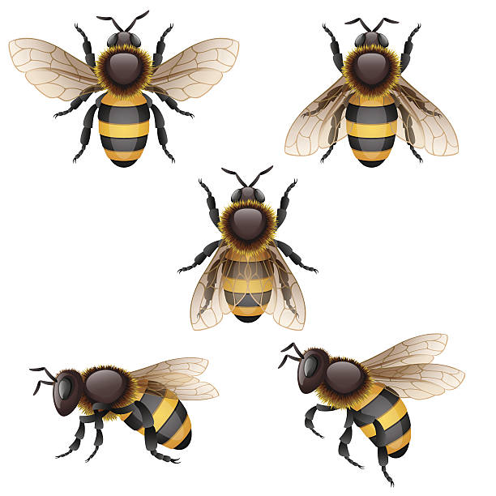

|  |  |  |  |  |  |  |  |  |  |
| --- | --- | --- | --- | --- | --- | --- | --- | --- | --- |
|  |  |  |  |  |  |  |  |  |  |
|  |  |  |  |  |  |  |  |  |  |
|  |  |  |  |  |  |  |  |  |  |
|  |  |  |  |  |  |  |  |  |  |
|  |  |  |  |  |  |  |  |  |  |
|  |  |  |  |  |  |  |  |  |  |
|  |  |  |  |  |  |  |  |  |  |
|  |  |  |  |  |  |  |  |  |  |
|  |  |  |  |  |  |  |  |  |  |
|  |  |  |  |  |  |  |  |  |  |
|  |  |  |  |  |  |  |  |  |  |

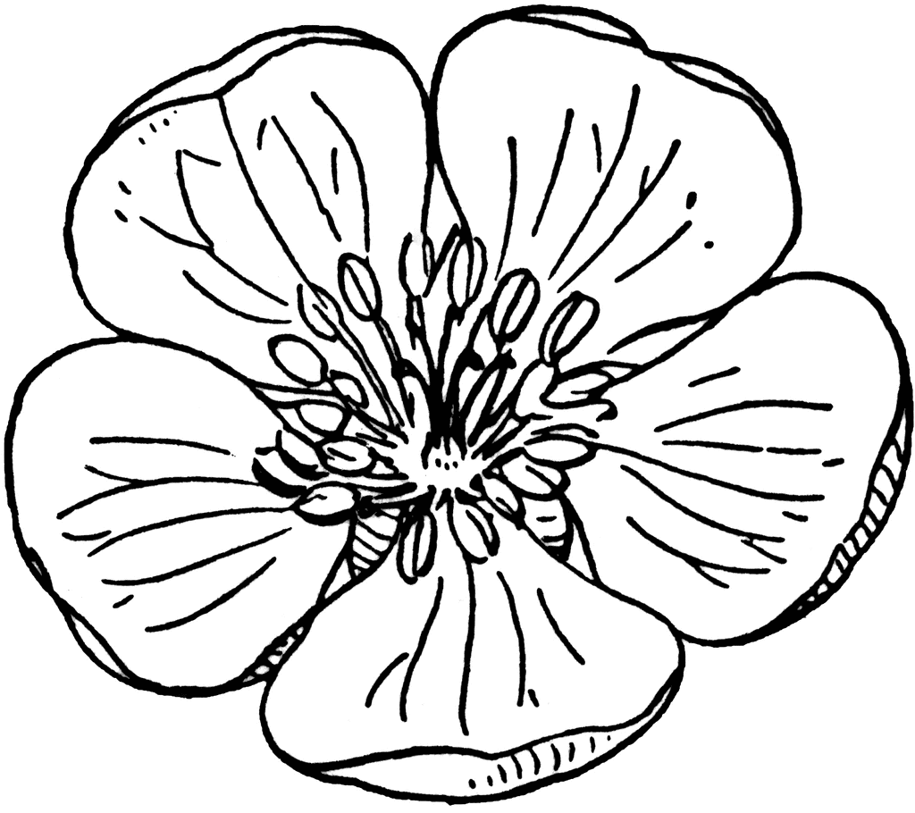

**Honeybees pollinate more than 100 different crop species!**

**Seed Match**

**Connect the correct disperser to their seed!**

