Palm Oil Grocery Search
Using Cheyenne Mountain Zoo’s Shopping App and/or guides, find 5 groceries in your home that are Orangutan-Friendly!

Orangutan-Friendly Shopping Guides and App info: https://www.cmzoo.org/conservation/orangutans-palm-oil/sustainable-palm-oil-shopping-app/

How to use the app:
- Download the app on a phone or other capable device.
- Scan the barcode of one of your groceries or quick search the product’s name.
- Look at the product’s rating of excellent (green), good (yellow), or needs improvement (orange).

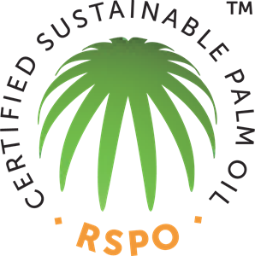
My list of Sustainable Palm Oil Products

- ___________________________________________
- ___________________________________________
- ___________________________________________
- ___________________________________________
- ___________________________________________

