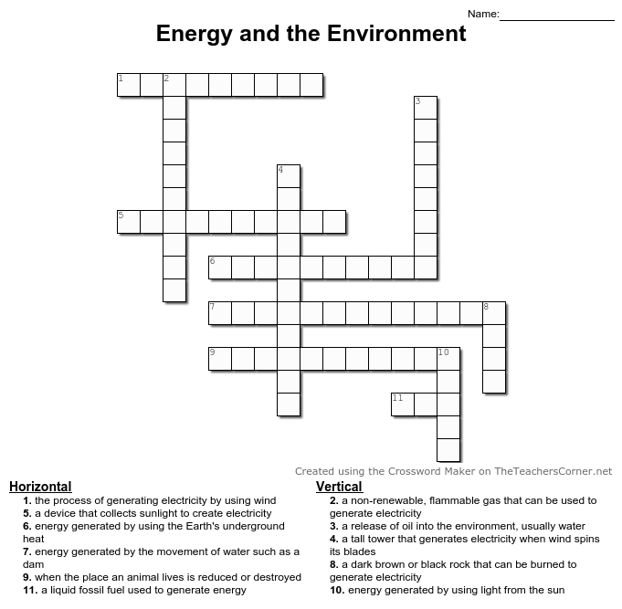

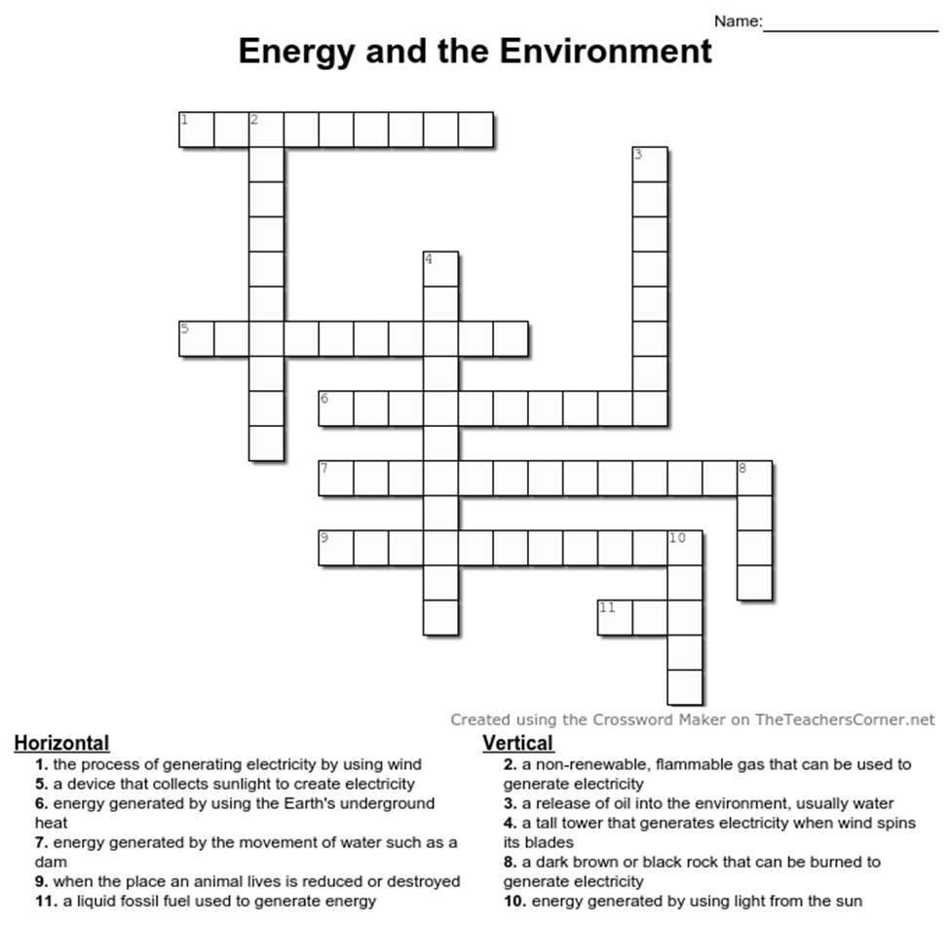

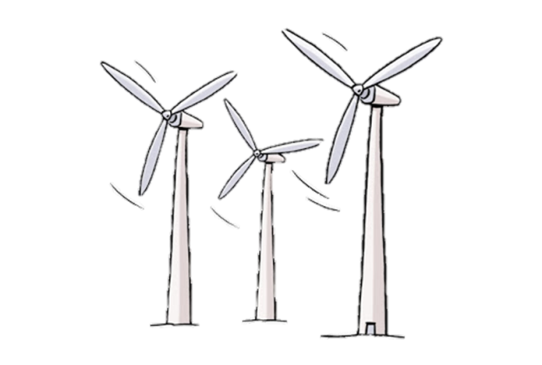

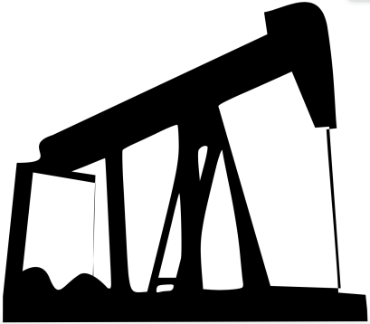



Answers: 1) wind power, 2) natural gas, 3) oil spill, 4) wind turbine, 5) solar panel, 6) geothermal, 7) hydroelectric, 8) coal, 9) habitat loss, 10) solar, 11) oil