Animal Groups Worksheet
Animal Groups: Mammals Birds Reptiles Amphibians Fish Invertebrates
List which animal groups have the following characteristics:
Characteristic | Animal Group(s)
No Backbone
Cold-blooded
Warm-blooded
Vertebrates

Circle the invertebrates:
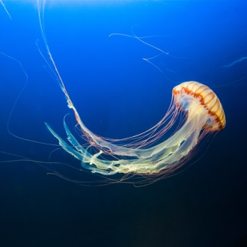
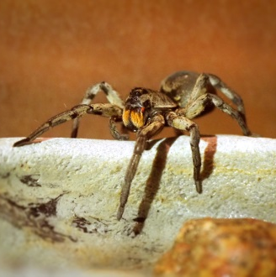
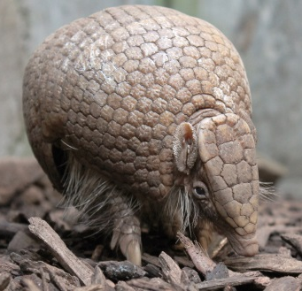
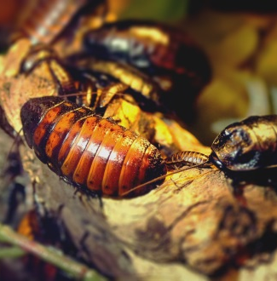

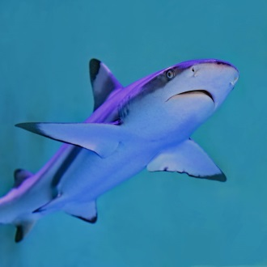
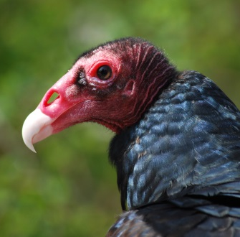

Draw a line to connect the animal to its correct group:
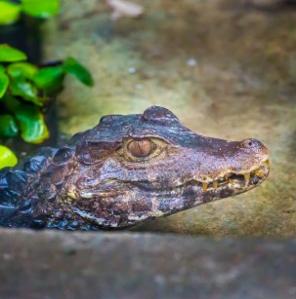
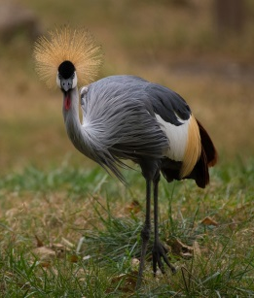
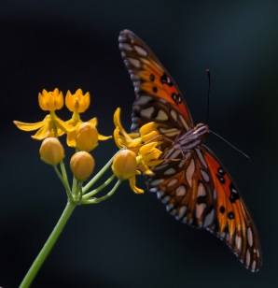
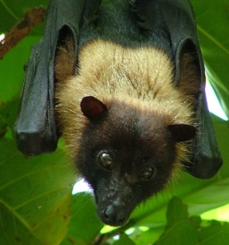
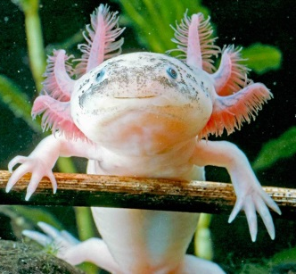
INVERTEBRATE AMPHIBIAN REPTILE BIRD MAMMAL
Answer true or false for the following questions:
- All mammals give live birth. True False
- Insects have exoskeletons. True False
- Birds and mammals both have four chambered hearts. True False
- Amphibians are warm-blooded. True False
- Reptiles go through metamorphosis. True False
- Newts breathe through their moist, semi-permeable skin. True False
- Bats have wings so they are a type of bird. True False

Name your favorite animal, list its animal group, and write what characteristics makes it part of that group.
Favorite animal: ______________________; Animal group: ____________________

Characteristics: _______________________________________________________

____________________________________________________________________

