Variation of Traits Worksheet
#1. Which of the following is an example of an inherited trait?
- Speaking two languages
- Scars
- Eye color
- Being able to fly

#2. Which of the following is an example of an acquired trait?
- Hair color
- Riding a bike
- Height
- Small nose

#3. Which of these factors can negatively affect a plant’s traits?
- Lack of water
- Good sunlight
- High quality soil
- All are positive factors

#4. Which of the following does not influence the traits of animals?
- The traits of their parents
- The traits of their grandparents
- The environment
- The traits of their friends

#5. If both mom and dad are big, their offspring will likely be what?
- Small
- Big
- Medium
- Microscopic

#6. Which of the following are different traits between these two cats?
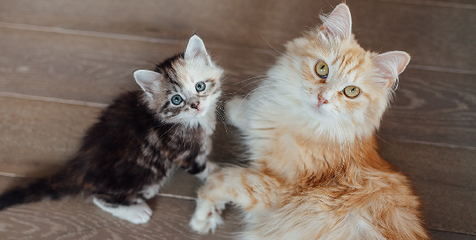
- Size
- Fur color
- Eye color
- All of the above

#7. Which trait would allow a deer the best chance to outrun a predator?
- Short legs
- Medium legs
- Long legs
- None of the above

#8. If you were a mouse in this picture, what color would you want to be to avoid the predator (bird)?
- Grey
- Tan
- Green
- Red

#9. Circle whether each of the following traits are inherited or acquired.

- A rhinoceros is big. Inherited Acquired

- A cheetah runs fast. Inherited Acquired

- A spider has long legs. Inherited Acquired

- A cactus has sharp spines. Inherited Acquired

- A dog can play fetch. Inherited Acquired

- A lion has a scar on its leg. Inherited Acquired

- A parrot can talk. Inherited Acquired

- A cat is fat from eating a lot. Inherited Acquired

- A rose has red petals. Inherited Acquired

- An owl has orange eyes. Inherited Acquired

- A penguin can swim quickly. Inherited Acquired
Answers: 1: C; 2: B; 3: A; 4: D; 5: B; 6: D; 7: C; 8: A; 9a: Inherited; 9b: Acquired; 9c: Inherited; 9d: Inherited; 9e: Acquired; 9f: Acquired; 9g: Acquired; 9h: Acquired; 9i: Inherited; 9j: Inherited; 9k: Acquired

