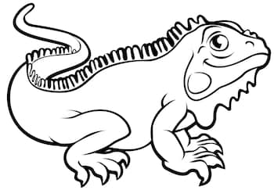
My Reptile Report
Reptiles have scales, are cold-blooded, are vertebrates, and breathe through lungs. Many lay eggs, although some give live birth. There are over 11,000 known species of reptiles worldwide—including 72 species in Kansas (turtles: 14, lizards: 16, snakes: 42)!

Reptile name: Draw a picture of your reptile:

_______________________________________

Type of reptile:
(snake, lizard, turtle, tuatara, or crocodilian)

_______________________________________

What does it eat?

_______________________________________

How long does it grow? How much does it weigh?
__________________________________________________________________________

______________________________________________ Color in where it is found:
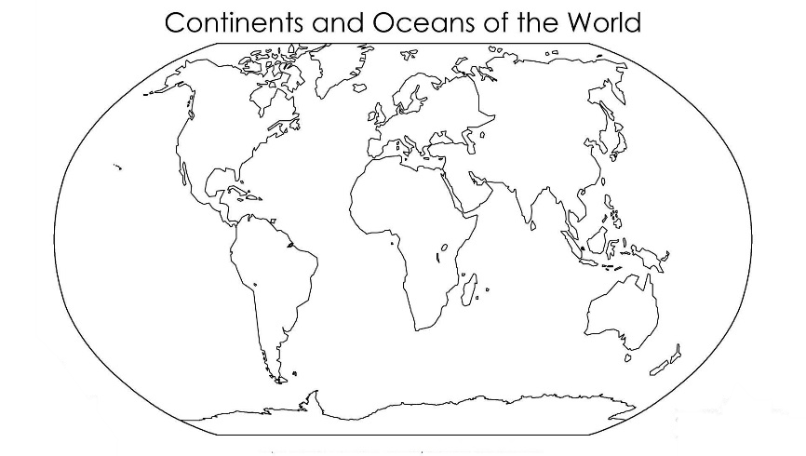
What is its lifespan?

_______________________________________

Ecosystem where it lives:
(Desert, prairie, woodlands, rainforest, etc.)

_________________________________________

Do females lay eggs or give live birth? How many?

__________________________________________________________________________

Do the parents take care of their young?

__________________________________________________________________________
What are its predators?

__________________________________________________________________________

What are its adaptations for survival (ie: camouflage, sharp teeth, fast swimmer)?

__________________________________________________________________________

__________________________________________________________________________

Is it endangered? If so, why?

__________________________________________________________________________

__________________________________________________________________________

How can humans help protect this reptile (ie: donate to certain organizations, not buy wildlife products, write a letter to government officials)?

__________________________________________________________________________

List two fun facts about the reptile that have not been covered in this worksheet:

#1. ________________________________________________________________________

__________________________________________________________________________

#2. _______________________________________________________________________

__________________________________________________________________________

