Energy Flow, Animals, and the Environment

- Picture #1 represents:
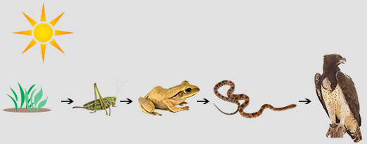
  - Metamorphosis
Picture #1
  - An energy pyramid
  - A food chain
  - A life cycle

- Picture #2 represents:
  - A food web
  - An animal web
  - A food graph
  - An animal graph

- Which organism in Picture #1 is not a consumer?
  - The grasshopper
  - The snake
  - The hawk
  - The grass

- Food chains and food webs show the flow of ____________ through an ecosystem.
  - Oxygen
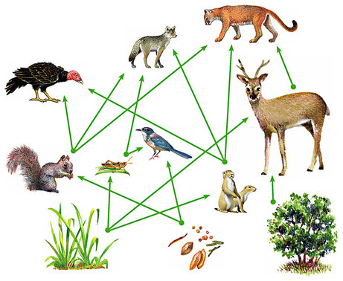
  - Energy
Picture #2
  - Nitrogen
  - Carbon dioxide

- What does a herbivore eat?
  - Plants and other animals
  - Only dead animals
  - Only plants
  - Only live animals

- In Picture #2, which animal does not eat the grass?
  - The grasshopper
  - The squirrel
  - The prairie dogs
  - The deer

- Which of the following is not a producer in Picture #2?
  - The grasshopper
  - The grass
  - The berries and nuts
  - The tree

- True or false: The blue bird in Picture #2 is an omnivore. Circle the correct answer. True False
- Using the word bank, fill in each box below:
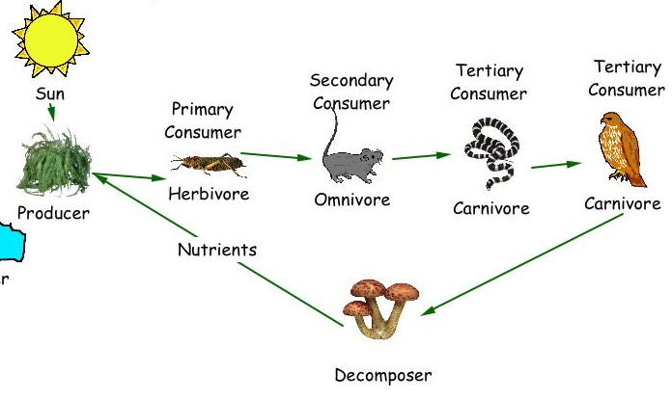

_________________

_____________
Consumer

_____________
Consumer

_____________
Consumer

_____________
Consumer

_____________________

Word bank:
Decomposer Secondary (2nd)
Tertiary (3rd) Producer
Primary (1st) Quaternary (4th)
Picture #3

- Which is the following is not an example of a scavenger?
  - Turkey vulture
  - Fungi
  - Opossum
  - Coyote

- True or False? As an omnivore, the mouse in Picture #3 always eats other animals. Circle your answer.
True False
- The energy in animals’ food is used for what?
  - Body repair
  - Growth
  - Motion
  - All of the above

- True or false? Food provides humans and other animals with energy. This energy was once energy from the sun that was captured by plants. Circle your answer.
True False
Answers: 1.) A food chain (c) 2.) A food web (a) 3.) The grass (d) 4.) Energy (b) 5.) Only plants (c) 6.) The squirrel (b)
7.) The grasshopper (a) 8.) True 9.) Under plant=producer; Under mushroom= decomposer; Over grasshopper=primary; Over mouse= secondary; Over snake=tertiary; over hawk=quaternary; 10.) Fungi (b); 11.) False; The mouse could also eat plants. 12.) All of the above (d) 13.) True

