Baby Animal Sounds: Memory Matching Game

Instructions: Cut out the 12 pieces and place them face down in front of you randomly. Flip over two cards at a time. Try to match each baby animal to the sound it makes! Once you have successfully matched an animal to its sound, you can take that animal and its sound cards off the memory board. Play until all the pieces are matched up!

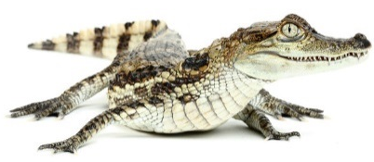  Young alligators (called a “hatchlings”) | Chirp for mom to protect them! | 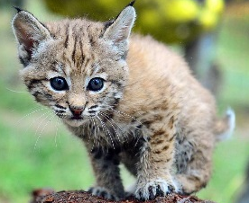  Young bobcats (called “kittens”) | Cry or mew when hungry or scared!
Young owls (called “owlets”)  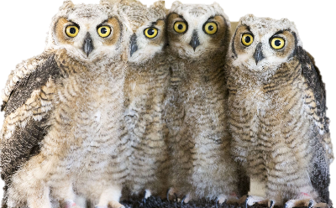 | Piercing screams when hungry! | Young chickens (called “chicks”) | Cheep when hungry, cold, or thirsty!
Young cows (called “calves”)  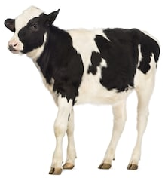 | Deep moos & bellows when hungry! | Young raccoons (called “kits”)  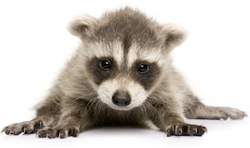 | Chatter as a way to stay with mom & siblings!

